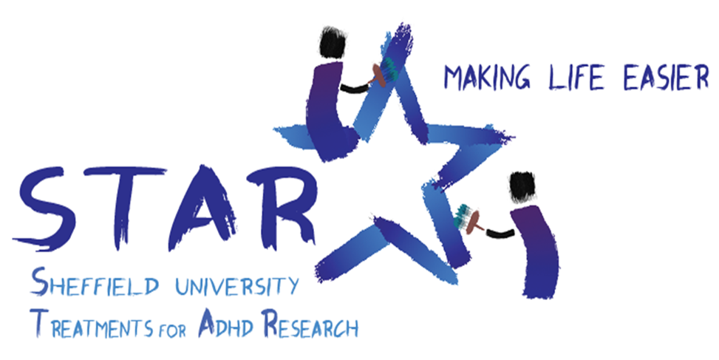

Summary of the STAR project.
The aim of the STAR project is to test treatments which might help those with ADHD. We report the results of the first stage of this project here.
We set up the STAR cohort, a database of children with diagnoses of ADHD, between September 2015 and 2016. Every 6 months we asked their carers and teachers to fill in a brief questionnaire about the child which included their ADHD symptoms and health-related quality of life. We then identified two non-mainstream treatments which are being used by families and randomly allocated some children to be offered these treatments: some were offered treatment by homeopaths, and some treatment by nutritional therapists. The treatments were additional, since all children continued with their usual care. After 6 months, we compared the results of those offered these treatments with the results of those who were not offered them.

Results.
A total of 144 families filled in the STAR questionnaire (www.starsheffield.com). We offered 42 treatment by homeopaths (23 took up this offer); and 42 treatment by nutritional therapists (27 took up the offer).
The main measurement we considered was the Conners Global ADHD Index (CGI), which asks 10 questions about life with ADHD. Some of the questions relate to emotions, such as temper outbursts, crying easily, or having mood swings. The rest relate to being inattentive or restless, such as being excitable, fidgety, disturbing other children and failing to finish things. Not everyone returned the 6 month and 12-month questionnaires. We had 34 questionnaires filled in by teachers (which was too few to analyse), and 88 questionnaires filled in by carers.
After 6 months of treatment we found that carers reported that both treatments were more effective compared to those who continued with their usual care. Those having homeopathic treatment reported that it particularly helped with their children’s emotional issues. Those having nutritional therapy reported that it particularly helped improve their children’s restlessness and inattention. The graph below shows this:

We also found that children’s health related quality of life improved. This was measured by asking 9 questions about worries, sadness, pain, tiredness, annoyance, homework, sleep, joining in, and daily routine.
Carers said the children had less concerns with annoyance, sadness, and pain after 6 months treatment by homeopaths, and less concerns with worry, sadness, and pain after treatment by nutritional therapists. They didn’t think either treatment made a difference to problems with schoolwork, management of daily routine, sleep, or joining in. The graph below shows three lines representing overall measurement of the health-related quality of life of the three groups (homeopathy, nutritional therapy and treatment as usual) before treatment started, and after 6 months. It shows that the health-related quality of life of those having a treatment improved, whilst those continuing with their usual care declined.

Although these results suggest that carers found the treatments more helpful for their children than continuing with their usual care, currently the numbers are too few to be sure. We also don’t yet know what the teachers thought, and their opinions are important because school is where lots of the difficulties with ADHD occur.

What next?
The next stage will be a larger scale trial. We will recruit 400 - 500 more families to the STAR cohort. Families can join up any time via www.starsheffield.com. We are also working on better ways to contact teachers and families. We have some funding for the next stage and are now seeking funding for the nutritional therapy treatment. If you can contribute, or know anyone who might be able to help, please let us know.
The STAR project is attracting lots of interest. One of the most exciting parts of the project was the show that was created about ADHD with a slam poet/rap-artist for Sheffield’s festival of the Mind. The videoed performance can be seen via this link (Festival of the Mind - Lost Voices performance). More recently, we have just heard that we are finalists for a Complementary Therapy Award; and we will be talking about ADHD during ADHD awareness month, as part of a show called Rewired at the Royal Geographic Society.
If you have any questions, comments, ideas or feedback we would love to hear from you.

Yours
Philippa Fibert (Principle Investigator)
Clare Relton (Project manager)
07543 345046 p.fibert@sheffield.ac.uk
www.starsheffield.com
https://www.facebook.com/starsheffieldADHD

